**Project Report**

1. **Are the changes in the number of Covid-19 active cases correlated to the changes observed in Australia’s air quality in the first half of 2020?**

The R-value indicates weak to no strength of correlation for air quality measures PM2.5 and CO and the virus. This value is below 0.3 for both PM2.5 (0.12) and CO (0.27) measures. The R-squared value tells us that only 1.5% of the variation of the median PM2.5 values and 7.6% of the variation of the median CO value is due to the virus in Australia.

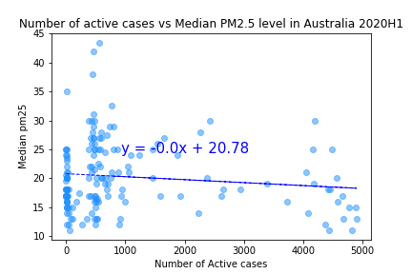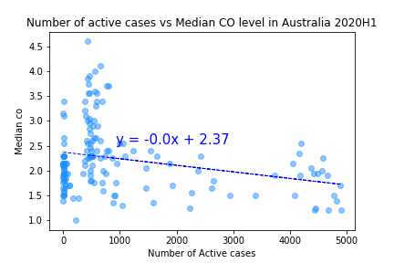

1. **Are the changes in the number of Covid-19 active cases correlated to the changes observed in India’s air quality in the first half of 2020? What comparisons can be drawn between Australia and India?**

In India overall, we found a weak to moderate negative correlation between number of active Covid-19 cases and air quality measures PM2.5 and CO in 2020. The R-value is 0.55 for PM2.5 which indicates a moderate (0.3 to <0.5) strength of correlation. For CO, the R-value is 0.46 indicating a weak strength of correlation. Here the R-squared value tells us that 31% of the variation of the median PM2.5 values and 21% of the variation of the median CO value is due to the virus in India.

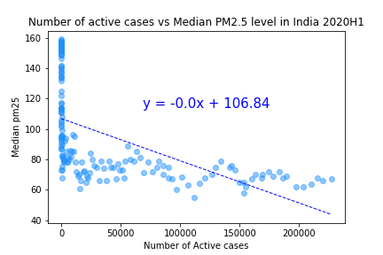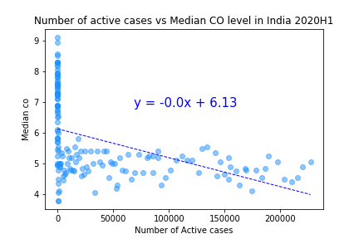

1. **Are the changes in the number of Covid-19 active cases correlated to the changes observed in the world’s air quality in the first half of 2020?**

For the world we found a strong negative correlation between the number of active Covid-19 cases and median PM2.5 values in 88 countries in 2020. For CO the R-value indicated weak to moderate strength of correlation. Here the R-squared value tells us that 58% of the variation of the median PM2.5 values and 25% of the variation of the median CO value is due to the virus.

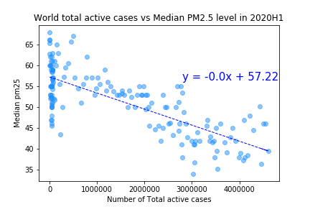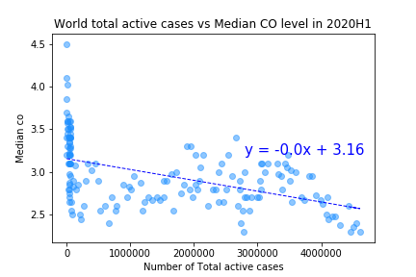

Overall, our data supports our hypothesis that air quality has been impacted by Covid-19. In addition, there are greater impacts on air quality in developing countries. However, the impacts on air quality are not as strong as we predicted. In summary, whilst we can’t predict everything with linear regression (as there are always going to be outliers) we can safely say that for future pandemics, like Covid-19, will result in an improvement in air quality for PM2.5 throughout the world. Developing countries will see a greater improvement in air quality compared to developed countries.